1. Change my password
2. Actors: User
3. Steps:

|  |  |
| --- | --- |
| Actor | System |
| 1. Enter username and password and select login.   Login Screen: | 1. Display login confirmation.   Login Confirmation: |
| 1. Select “OK” button. | 1. Display UI for user type. This example will use an admin.   Main Admin UI: |
| 1. Select “Manage Account” button. | 1. Display “Manage Account” page.   Manage Account Page: |
| 1. Select “Change Password” button. | 1. Display “Update Account Information” screen.   Update Account Information Screen: |
| 1. Enter old password and new password and select “Save.”   Update Account Information Screen with Old and New password: | 1. Display “User Update Confirmation” screen.   User Update Confirmation Screen: |
| 1. Select “OK” button. | 1. Display Main Admin UI. |

1. Add a new user into the system
2. Actors: Admin, User
3. Steps:

|  |  |
| --- | --- |
| Actor | System |
| 1. Enter username and password and select login.   Login Screen: | 1. Display login confirmation.   Login Confirmation: |
| 1. Select “OK” button. | 1. Display “Main Admin” UI.   Main Admin UI: |
| 1. Select “Add User” button. | 1. Display “Add User” screen.   Add User Screen: |
| 1. Enter user’s information and click button “Add.”   Add User Screen with Information: | 1. Display “Add User Confirmation.”   Add User Confirmation Screen: |
| 1. Select “OK” button. | 1. Display “Main Admin UI.” |

1. Promote a user from cashier to manager
2. Actors: Admin, User
3. Steps:

|  |  |
| --- | --- |
| Actor | System |
| 1. Enter username and password and select login.   Login Screen: | 1. Display login confirmation.   Login Confirmation: |
| 1. Select “OK” button. | 1. Display “Main Admin” UI.   Main Admin UI: |
| 1. Select “Update User” button. | 1. Display “Load User” screen.   Load User Screen: |
| 1. Input username and click “Load User” button.   Load User Screen with Username: | 1. Display “Update Account Information” screen.   Update Account Information Screen: |
| 1. Select manager as the user’s type, input password, and click button “Save.”   Update Account Information Screen with new type and password: | 1. Display “User Update Confirmation.”   User Update Confirmation Screen: |
| 1. Select “OK” button. | 1. Display “Main Admin UI.” |

1. Add a new product into the system
2. Actors: Manager
3. Steps:

|  |  |
| --- | --- |
| Actor | System |
| 1. Enter username and password and select login.   Login Screen: | 1. Display login confirmation.   Login Confirmation: |
| 1. Select “OK” button. | 1. Display “Main Manager” UI.   Main Manager UI: |
| 1. Select “Add Product” button. | 1. Display “Add Product” screen.   Add Product Screen: |
| 1. Enter new product’s information and click button “Add.”   Add Product Screen with new Product’s Information: | 1. Display “Add Product Confirmation.”   Add Product Confirmation Screen: |
| 1. Select “OK” button. | 1. Display “Main Manager UI.” |

1. View a summary report of sales from the current system
2. Actors: Manager
3. Steps:

|  |  |
| --- | --- |
| Actor | System |
| 1. Enter username and password and select login.   Login Screen: | 1. Display login confirmation.   Login Confirmation: |
| 1. Select “OK” button. | 1. Display “Main Manager” UI.   Main Manager UI: |
| 1. Select “View Sales Report” button. | 1. Display “Sales Report” screen.   Sales Report Screen: |
| 1. Click x button at the top of the window. | 1. Display “Main Manager UI.” |

1. Update a customer’s address
2. Actors: Cashier, Customer
3. Steps:

|  |  |
| --- | --- |
| Actor | System |
| 1. Enter username and password and select login.   Login Screen: | 1. Display login confirmation.   Login Confirmation: |
| 1. Select “OK” button. | 1. Display “Main Cashier” UI.   Main Cashier UI: |
| 1. Select “Update Customer” button. | 1. Display “Update Customer” screen.   Update Customer Screen: |
| 1. Input customer’s ID and click “Load Customer” button   Update Customer Screen with Customer ID: | 1. Display “Update Customer” screen with customer’s information.   Update Customer Screen with Customer’s Information: |
| 1. Enter customer’s new address, and click button “Update.”   Update Customer Screen with Customer’s Information and new Address: | 1. Display “Update Customer Confirmation.”   Update Customer Confirmation Screen: |
| 1. Select “OK” button. | 1. Display “Main Cashier UI.” |

1. Update the quantity of an item purchased
2. Actors: Cashier, Customer
3. Steps:

|  |  |
| --- | --- |
| Actor | System |
| 1. Enter username and password and select login.   Login Screen: | 1. Display login confirmation.   Login Confirmation: |
| 1. Select “OK” button. | 1. Display “Main Cashier” UI.   Main Cashier UI: |
| 1. Select “Update Purchase” button. | 1. Display “Update Purchase” screen.   Update Purchase Screen: |
| 1. Input purchase’s ID and click “Load Purchase” button   Update Purchase Screen with Purchase ID: | 1. Display “Update Purchase” screen with purchase’s information   Update Purchase Screen with Purchase Information: |
| 1. Enter new quantity for purchase and click button “Save Purchase.”   Update Purchase Screen with Purchase Information and new Quantity: | 1. Display “Update Purchase Confirmation.”   Update Purchase Confirmation Screen: |
| 1. Select “OK” button. | 1. Display “Purchase Receipt” screen.   Purchase Receipt: |
| 1. Select “OK” button. | 1. Display “Main Cashier UI.” |

1. Make a purchase
2. Actors: Customer
3. Steps:

|  |  |
| --- | --- |
| Actor | System |
| 1. Enter username and password and select login.   Login Screen: | 1. Display login confirmation.   Login Confirmation: |
| 1. Select “OK” button. | 1. Display “Main Customer” UI.   Main Customer UI: |
| 1. Select “Add Purchase” button. | 1. Display “Add Purchase” screen.   Add Purchase Screen: |
| 1. Enter information for purchase and click button “Add.”   Add Purchase Screen with Information: | 1. Display “Add Purchase Confirmation.”   Add Purchase Confirmation: |
| 1. Select “OK” button. | 1. Display “Purchase Receipt” screen.   Purchase Receipt: |
| 1. Select “OK” button. | 1. Display “Main Customer UI.” |

1. View my purchase history
2. Actors: Customer
3. Steps:

|  |  |
| --- | --- |
| Actor | System |
| 1. Enter username and password and select login.   Login Screen: | 1. Display login confirmation.   Login Confirmation: |
| 1. Select “OK” button. | 1. Display “Main Customer” UI.   Main Customer UI: |
| 1. Select “View Purchase History” button. | 1. Display “Purchase History” screen.   Purchase History Screen: |
| 1. Click x button at the top of the window. | 1. Display “Main Customer UI.” |

1. Search for what berries the store has available.
2. Actors: Customer
3. Steps:

|  |  |
| --- | --- |
| Actor | System |
| 1. Enter username and password and select login.   Login Screen: | 1. Display login confirmation.   Login Confirmation: |
| 1. Select “OK” button. | 1. Display “Main Customer” UI.   Main Customer UI: |
| 1. Select “Search for Product” button. | 1. Display “Product Search” screen.   Product Search Screen: |
| 1. Enter “berries,” and click button “Search.”   Product Search Screen with Product Name: | 1. Display “Search Results” screen.   Search Results Screen: |
| 1. Click x button at the top of the window. | 1. Display “Main Customer UI.” |

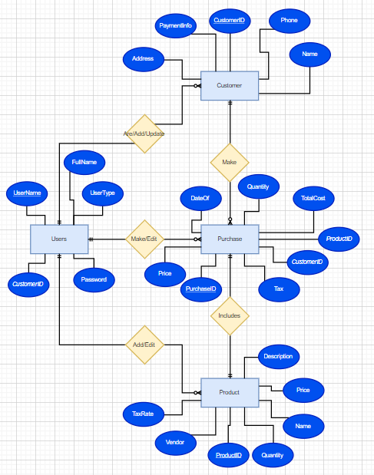

Entity:

Product(**ProductID**, Name, Price, TaxRate, Quantity, Vendor, Description)

Customer(**CustomerID**, Name, Address, Phone, PaymentInfo)

Purchase(**PurchaseID**, *ProductID*, *CustomerID*, Quantity, Cost, TaxCost, TotalCost, DateOf)

User(**UserName**, Password, UserType, FullName, *CustomerID*)